- Justify development choices for your 3D scene. Think about why you chose your selected objects. Also consider how you were able to program for the required functionality.
I chose desk, cup, pencil, laptop, eraser for my objects because they are commonly seen by people every day. I were able to program for the required functionality by combining simple shapes like cylinder, plane, and box.

- Explain how a user can navigate your 3D scene. Explain how you set up to control the virtual camera for your 3D scene using different input devices.
The user can use wasd to navigate forward, left, back, and right, respectively. They can also push q to move up and e to go down. I also assigned the p key to change perspective between 2d and 3d.

- Explain the custom functions in your program that you are using to make your code more modular and organized. Ask yourself, what does the function you developed do and how is it reusable?
I created a custom function to handle changing the perspective: 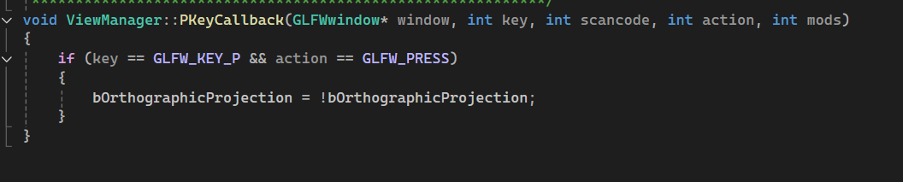
It keeps things organized by assigning a key that isn’t currently used by anything else. It also is reusable in that it is copy and paste as long as that key isn’t used by the new program.
I also modified the process mouse scroll function to make it more natural for users: by scrolling up they go faster and by scrolling down they go slower by changing the – to a + in MovementSpeed +=:
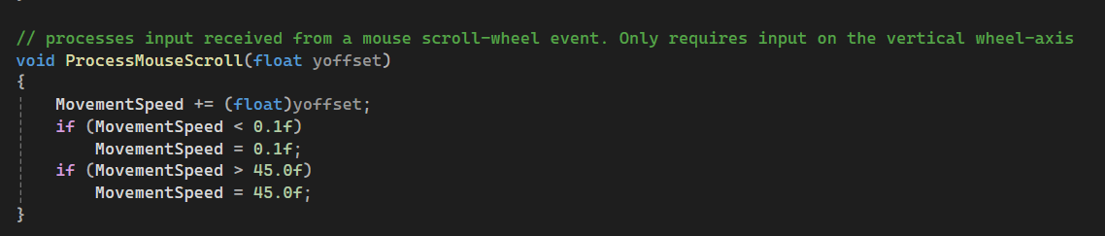
I also customized the LoadSceneLights function to include specific lights that would have ambient, diffuse, and specular qualities. In doing so, I can copy and paste the function to any project to have a lighting setup easily reusable and deployable.
I also customzed the LoadSceneTextures function to include textures I found – by putting those new textures there I kept the loading of textures still modularized in the same space/function. The code is also reusable as long as the user puts the files in the same relative position.

